Direct3D 10

Index Buffers

In this short worksheet you will work with an index buffer in addition to a vertex buffer. The use of two buffers helps separate the definition of the polygons from that of the vertices. It allows for the minimum number of vertices to be stored, important since we will soon see that vertices may contain considerable data. The only duplication will be of indexes, but they are merely integers, so this is little expense.
The vast majority of DirectX rendering uses index buffers.

Getting Started
- Download the IndexBuffer zip file from Week 9 of the CO2409 webpage
- Unzip it to your work folder and open the ‘IndexBuffer’ project
- Run it - you should see the previous 3D matrices project but displaying just a single square. You can use the ‘W’, ‘S’, ‘A’ & ‘D’ keys to spin the square
- All the important code is in Scene.cpp

Overview
Look at the changes needed to use an index buffer. New parts are marked ****NEW in the code:
- The geometry data at the top of the file, the gCubeVertices and gCubeIndices arrays now use index buffers. The vertex array now only contains the four vertices of the square – no duplication. The index array refers to rows in the vertex array.
- The function InitGeometry starts with he usual code to create a vertex buffer, but then there follow now code to initialize an index buffer too – it’s a very similar process.
- The main drawing call at the end of the RenderScene function has changed from Draw to DrawIndexed. There is one more parameter for this new form
- Look through these new sections, there are additional comments to clarify details

Exercises
- Add a second square that shares two vertices with the first one. You will need to add data to both the vertex & index arrays, as well as adjusting the DrawIndexed call in the Render function. Drawing a picture of the existing and new square, with the index numbers marked will help. Position / colour the new square as you wish

- In InitScene, find the block of code that sets the D3D11_CULL_NONE state (use search if you don’t see it). This code makes both sides of your triangles visible. However, drawing the insides of objects is a waste of time, so normally this is set to D3D11_CULL_BACK, which won’t draw inside faces. Change the code to use “cull_back” now, run your program, and rotate the square around. Can you work out what has happened (and why)? Can you work how to fix it by only changing the index data in the C++ code?

- Make a cube by adding more vertices and indices. You must draw a diagram of the cube with the indices marked to have a chance of doing this

Lab Assignment Stage 1: Demonstrate a cube that uses an index and vertex buffer, there should be no visual discrepancies in the cube.

- Advanced – Try to create an indexed triangle strip. Start by creating a single square, then try to extend it to become a cube in the next exercise.

- Advanced – In a previous lab, we made a cube out of three triangle strips. In fact it can be made out of a single strip with no redundancy. A diagram of the strip route is below:
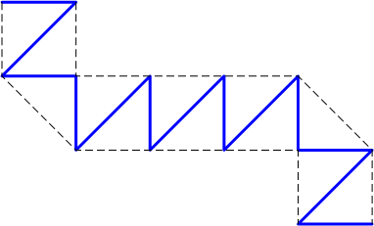

Create a single triangle strip cube following this diagram that uses an index buffer. Again, a carefully labelled diagram will be vital to get this right.

Lab Assignment Stage 2: Demonstrate a cube using a single triangle strip and an index and vertex buffer (Note: demonstrating this automatically demonstrates the Stage 1 requirement).

